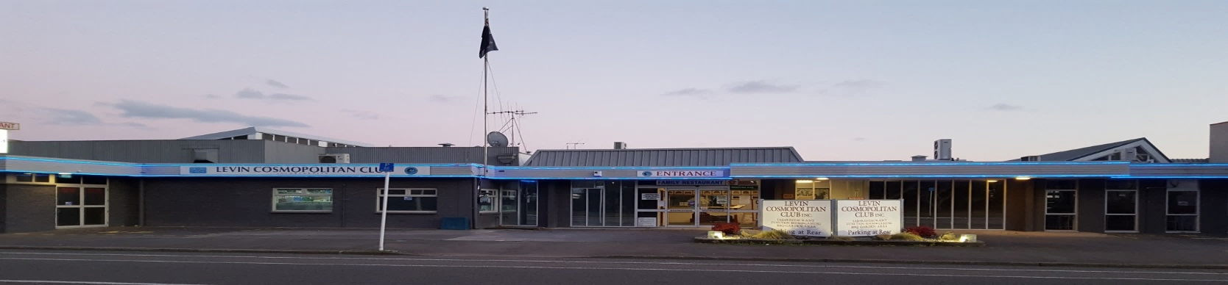
Levin Cosmopolitan Club Inc
January 2020 Newsletter

Hi Everyone and welcome to the new decade of the 2020’s. May it be successful and prosperous for all.

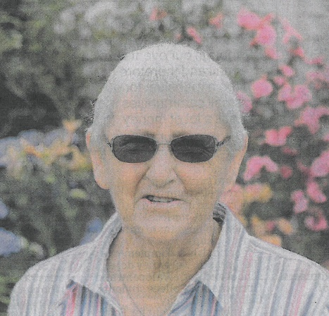
Congrats to “our very own” Carrell Knight being awarded a Queens Service Medal for services to Bowls in the New Year Honours List.

Carrell joined the Club in 2007 and has for several years also been the Secretary of the Club’s Sports Council, a very important and valuable role indeed.

Congrats Carrell from the Executive Committee, Management, Staff and Members.

Congrats also to Liam McLeavey (Grandson of Life Member John McLeavey). Liam was one of our 2018 Tertiary Grant recipients and has been handpicked as a Global Teen Leader of a select group of young people from 18 different countries to attend the 2020 Global Teen Leaders Summit in New York, USA March 27 – April 3. He is the only person chosen from either Australia or New Zealand, and from thousands of applicants worldwide. Well done Liam.

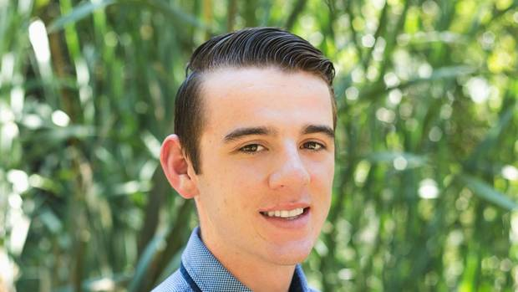

Within this newsletter are the names of the recipients of the Club’s 2019 Tertiary/Trades Grants. A total amount of $3,500 was awarded to seven recipients.

A friendly reminder to all Club Members that a reduced fee is payable, by LCC members on presentation of your current membership card, for WOF’s for your vehicle at the Levin Testing Station.

Cheers

Recipients of Tertiary/Trade Grants

The following were the successful recipients of this year’s Tertiary & Trade Grants. Congratulations and all the best for your future studies.

Billeigh Dawson-Hughes
Chloe Kemp
Morgan Kibblewhite
Josh Madgwick
Hannah Martin
Jayden Tupara
Jessica Marshall

***Restaurant Holiday Closure***

Please be aware our restaurant will be closed from Tuesday 4th February and will reopen on Tuesday 11th February. Apologies for any inconvenience. The hot food bar snacks in the main Bar will be opened throughout.

Super Rugby Tipping Game

We will start our tipping game from next week to make it fair on everyone who wants to enter, due to a delay in receiving the tipping cards from our Rep. $2.00 per week, cards will be available from the Bar.

Pool Cues

Due to Health & Safety protocols, sadly, members who currently have pool cues stored in behind the Main Bar area must uplift and take them back home forthwith. The Club is trying to find more appropriate storage for the future.
Thanks for your co-operation.

Cue Sports Adjunct

Happy New Year 8-Ballers

Thursday Night Club Nights
We began our Adjunct Club nights again on the 23rd Jan-2020. This will continue through to May, when the Business House League begins.
The evening begins every Thursday night from 7-00pm and the competition draw for the night will be made at 7-30pm. If you arrive after 7-30pm then you’re too late for the draw as we only have a limited time to get these games completed on the night.
The Adjunct Club night is for Adjunct members only so if you have not yet paid your sub for 2020, you can obtain a receipt on the night, by paying our Treasurer or any other Adjunct Committee member.

Housie Nights
Floor walkers/checkers are required in Feb and Mar from our Adjunct on Thursday nights.
Please see notice board for dates. The payment we receive for this service is to help fund the entry fees our members pay to attend tournaments. If you want funding assistance from the Adjunct then please put your name on the list.

Outside Tournaments coming up in Feb and Mar include:-
Spike Angove Memorial Pairs – Palmerston North
John King Memorial Masters Pairs – Waikanae
Lindauer Ladies Singles – Upper Hutt

Greater Wellington League
There is a list on our notice board where interested players can add their names to play in this League which begins on the 1st March. Please see notice for details.
Please keep yourself up to date with what’s happening in the 8-Ball calendar by checking the Adjunct notice board regularly.

Lots of luck
This Photo by Unknown Author is licensed under CC BY-NC
Dave Morris

Remembrance

It is with great sadness that we farewell the following members:

Colin Paki Member since July 1977
Grant Easton Member since July 1981

Our thoughts and condolences go out to their families and friends.

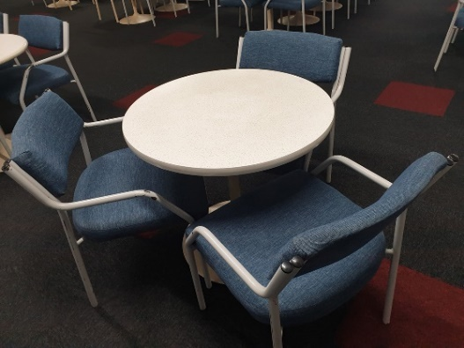
Table & Chairs For Sale

We still have available for purchase, sets of a small round table & 3 chairs – please see Jacqui in the office if you are interested in purchasing for $100.

Or purchase a pair of chairs for $40
Or a table for $40

Free Free

Anyone and Everyone is welcome to enjoy the contents of our takeaway shelf situated in the members lounge near to the start of the dart boards, which has a fantastic selection of donated DVD’s, CD’s and books for you to takeaway.

Thanks to the Club

The Club often receive thanks for grants we provide to the community. One such grant was to the Horowhenua Hearing Asscoiation to help them purchase the MedRX UltraVac Machine, which they now have and put to vital use.

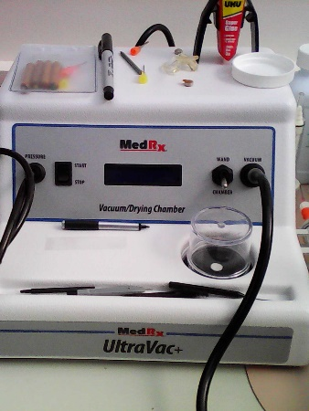

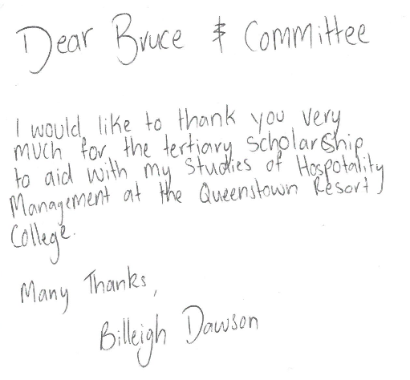
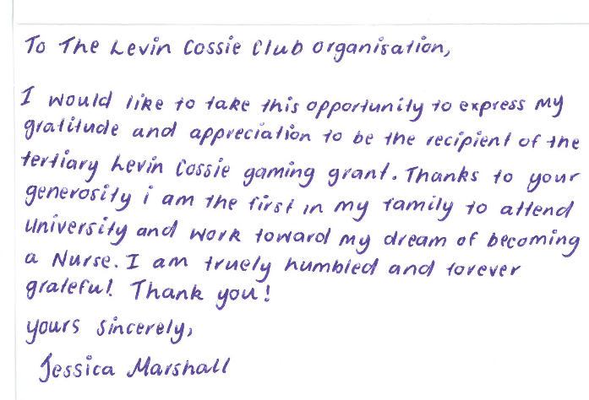
We received thanks from all the Tertiary/Trades grant recipients, a couple of which are below:
As Hannah's Mother I would like to thankyou for your very kind donation towards Hannahs tertiary education.

Hannah is very much looking forward to developing her hospitality and culinary skills as she leaves Levin to study in the Bay of Islands with the Queenstown Resort College in 2020.

We are hopeful she will continue to apply herself diligently, further her passion in the culinary arts and be a blessing to the community and those around her as she develops her culinary skills.

Thankyou once again and wishing you all a very happy new year.

Kind Regards
Sherry Martin

Thank you so much Jacqui. He just got a list of all the equipment he needs before Xmas. The money will help him get the things he needs to start his course next year.
Hope

We also received a thank you letter from the Levin & Districts Brass Inc for our contribution to their Big Dig held at Waitarere Beach on the 2nd January

And another letter from the Levin Interchurch Foodbank for the gift of foodstuffs our members and Club provided. They asked us to pass on their thanks to our members who have contributed so generously.

It is so lovely to receive these acknowledgements, and to know we’ve been able to help our community.
Up Coming Events

Friday 7th February Karaoke with Nigel 8pm
Sunday 9th February Nick Simmons (Garden Area) 3pm – 6pm
Saturday 15th February Housie Fundraiser 12pm
Friday 21st February Karaoke with Trevor
Sunday 23rd February Country & Variety Music Club 1pm – 5pm $4 entry
Sunday 23rd February Music in the Garden 3pm – 6pm
Saturday 29th February Live Band: Just Us Duo
Friday 6th March Karaoke with Nigel 8pm
Sunday 8th March Music in the Garden 3pm – 6pm
Saturday 14th March Country Music Club 1pm to 5pm
Friday 20th March Karaoke with Trevor 8pm
Sunday 22nd March Music in the Garden 3pm – 6pm
Saturday 28th March Live Band: Harmony Showdown 8pm
Sunday 29th March Country & Variety Music Club 1pm – 5pm $4 entry

